**Precipitation and Trends from Waterville**

Dr. Danielle Wain, 7 Lakes Alliance

Mann Kendall trend analysis was conducted on the precipitation and snow records over three time periods: the entire record (1896-2021), the record overlapping with water quality data (1977-2021), and the past 10 years (2012-2021). The only record with a statistically significant trend was precipitation over the entire record, which indicates an increase in rainfall in that period. Note that no units were provided with the data but presumably these are inches based on the range of values

Entire record (1896 – 2021):

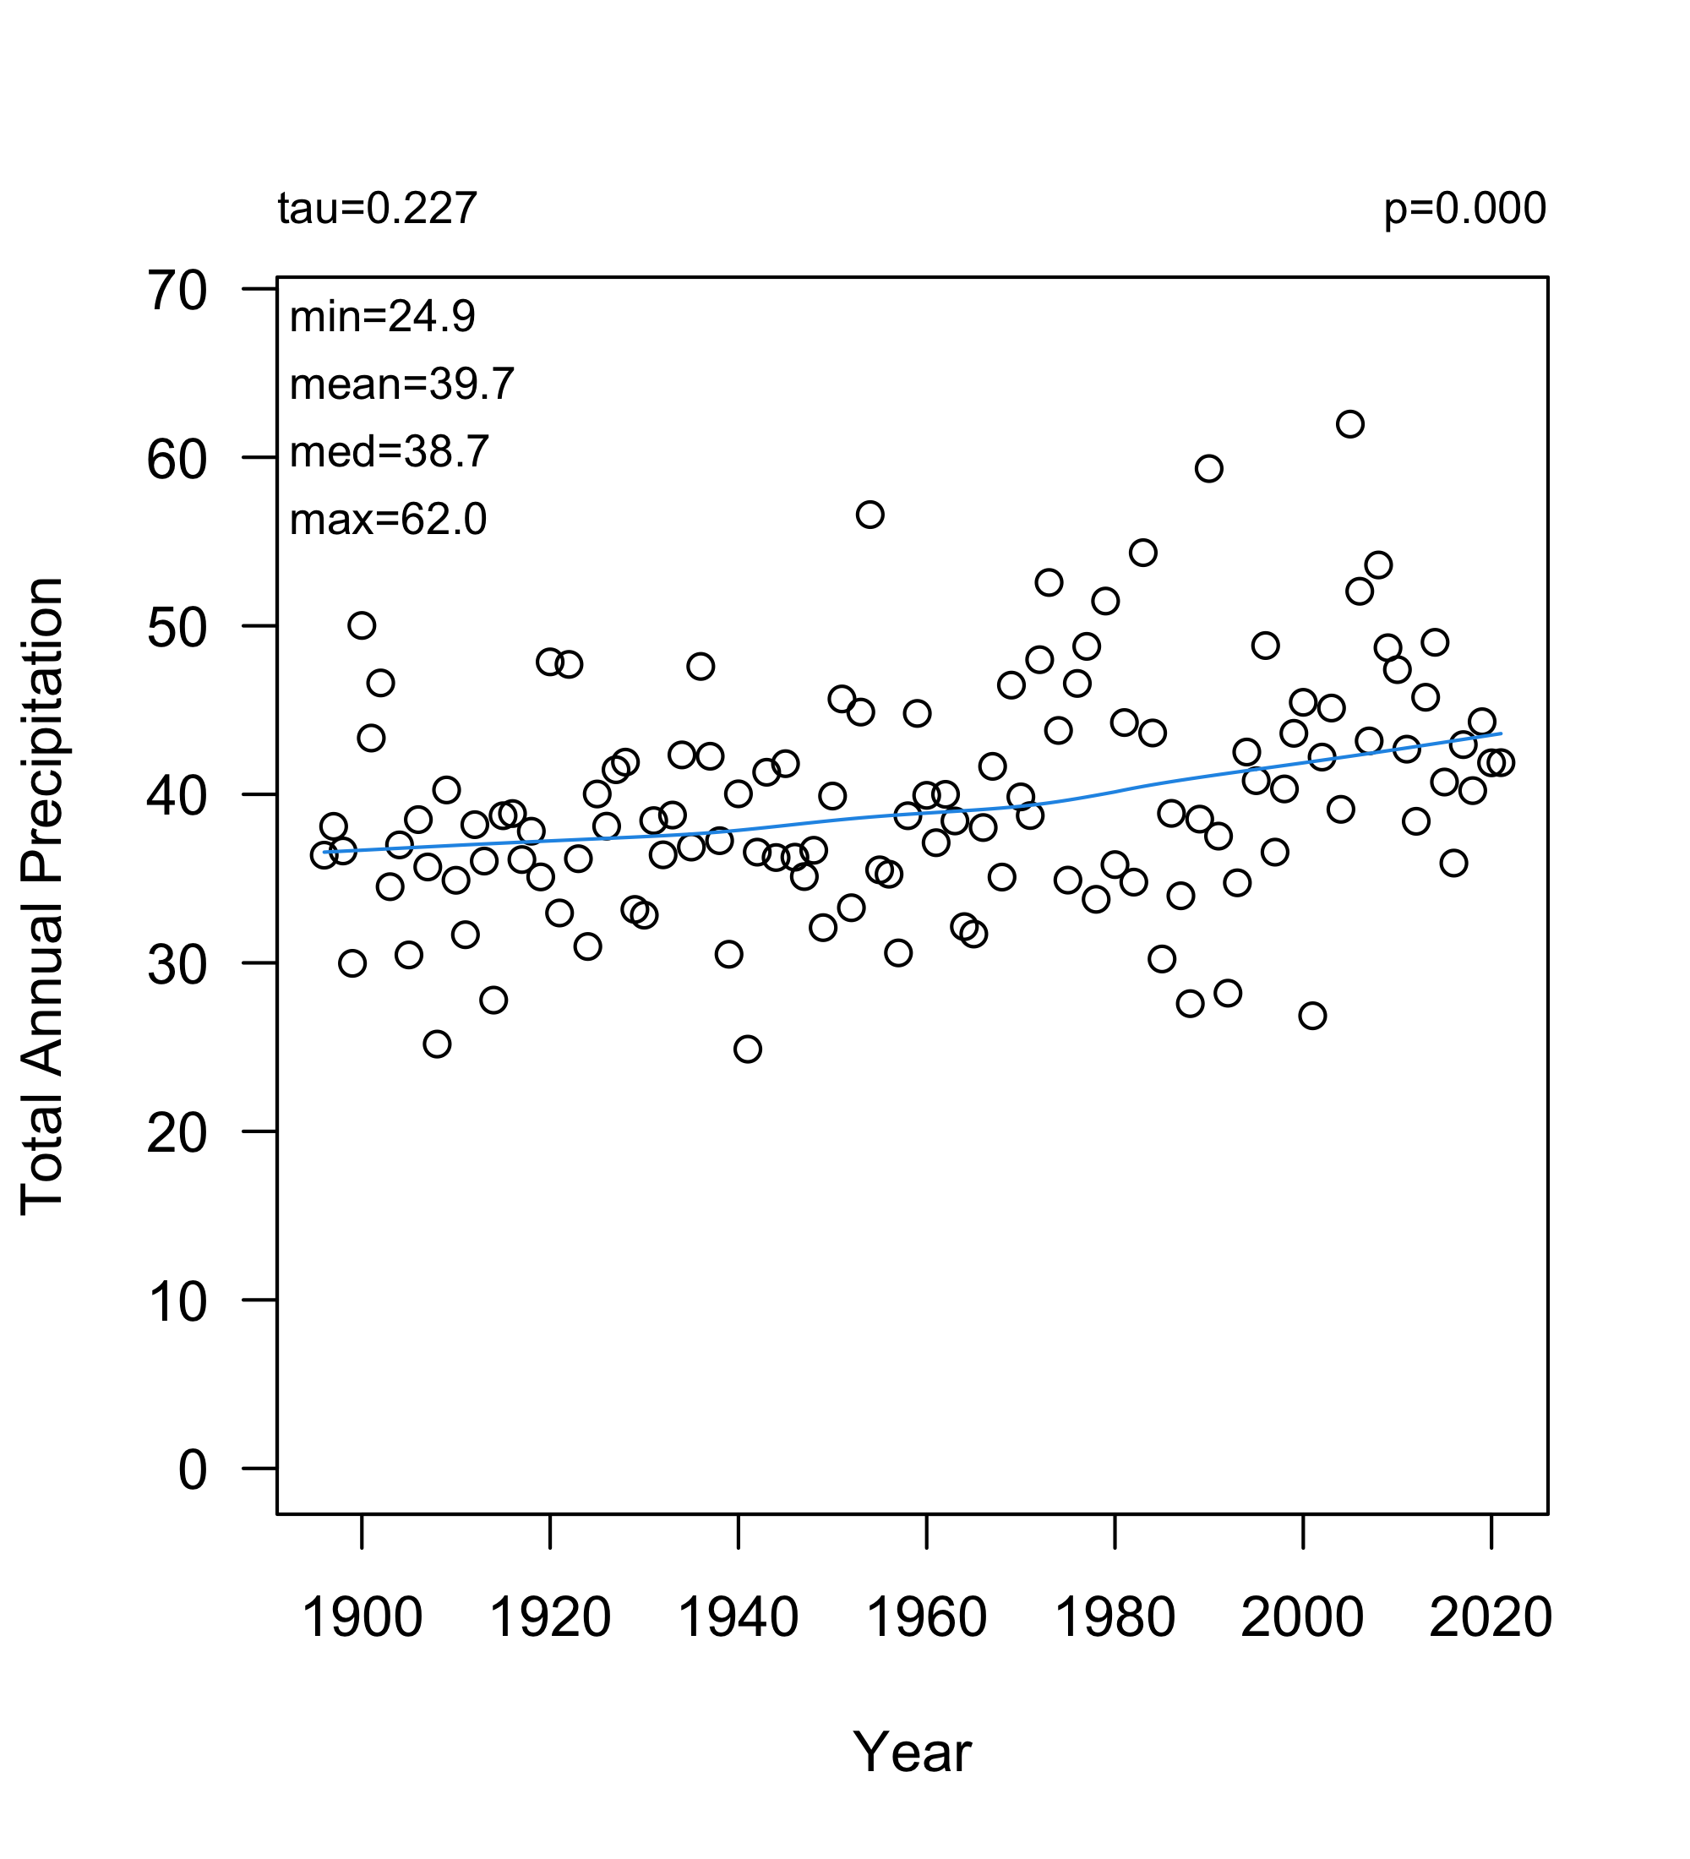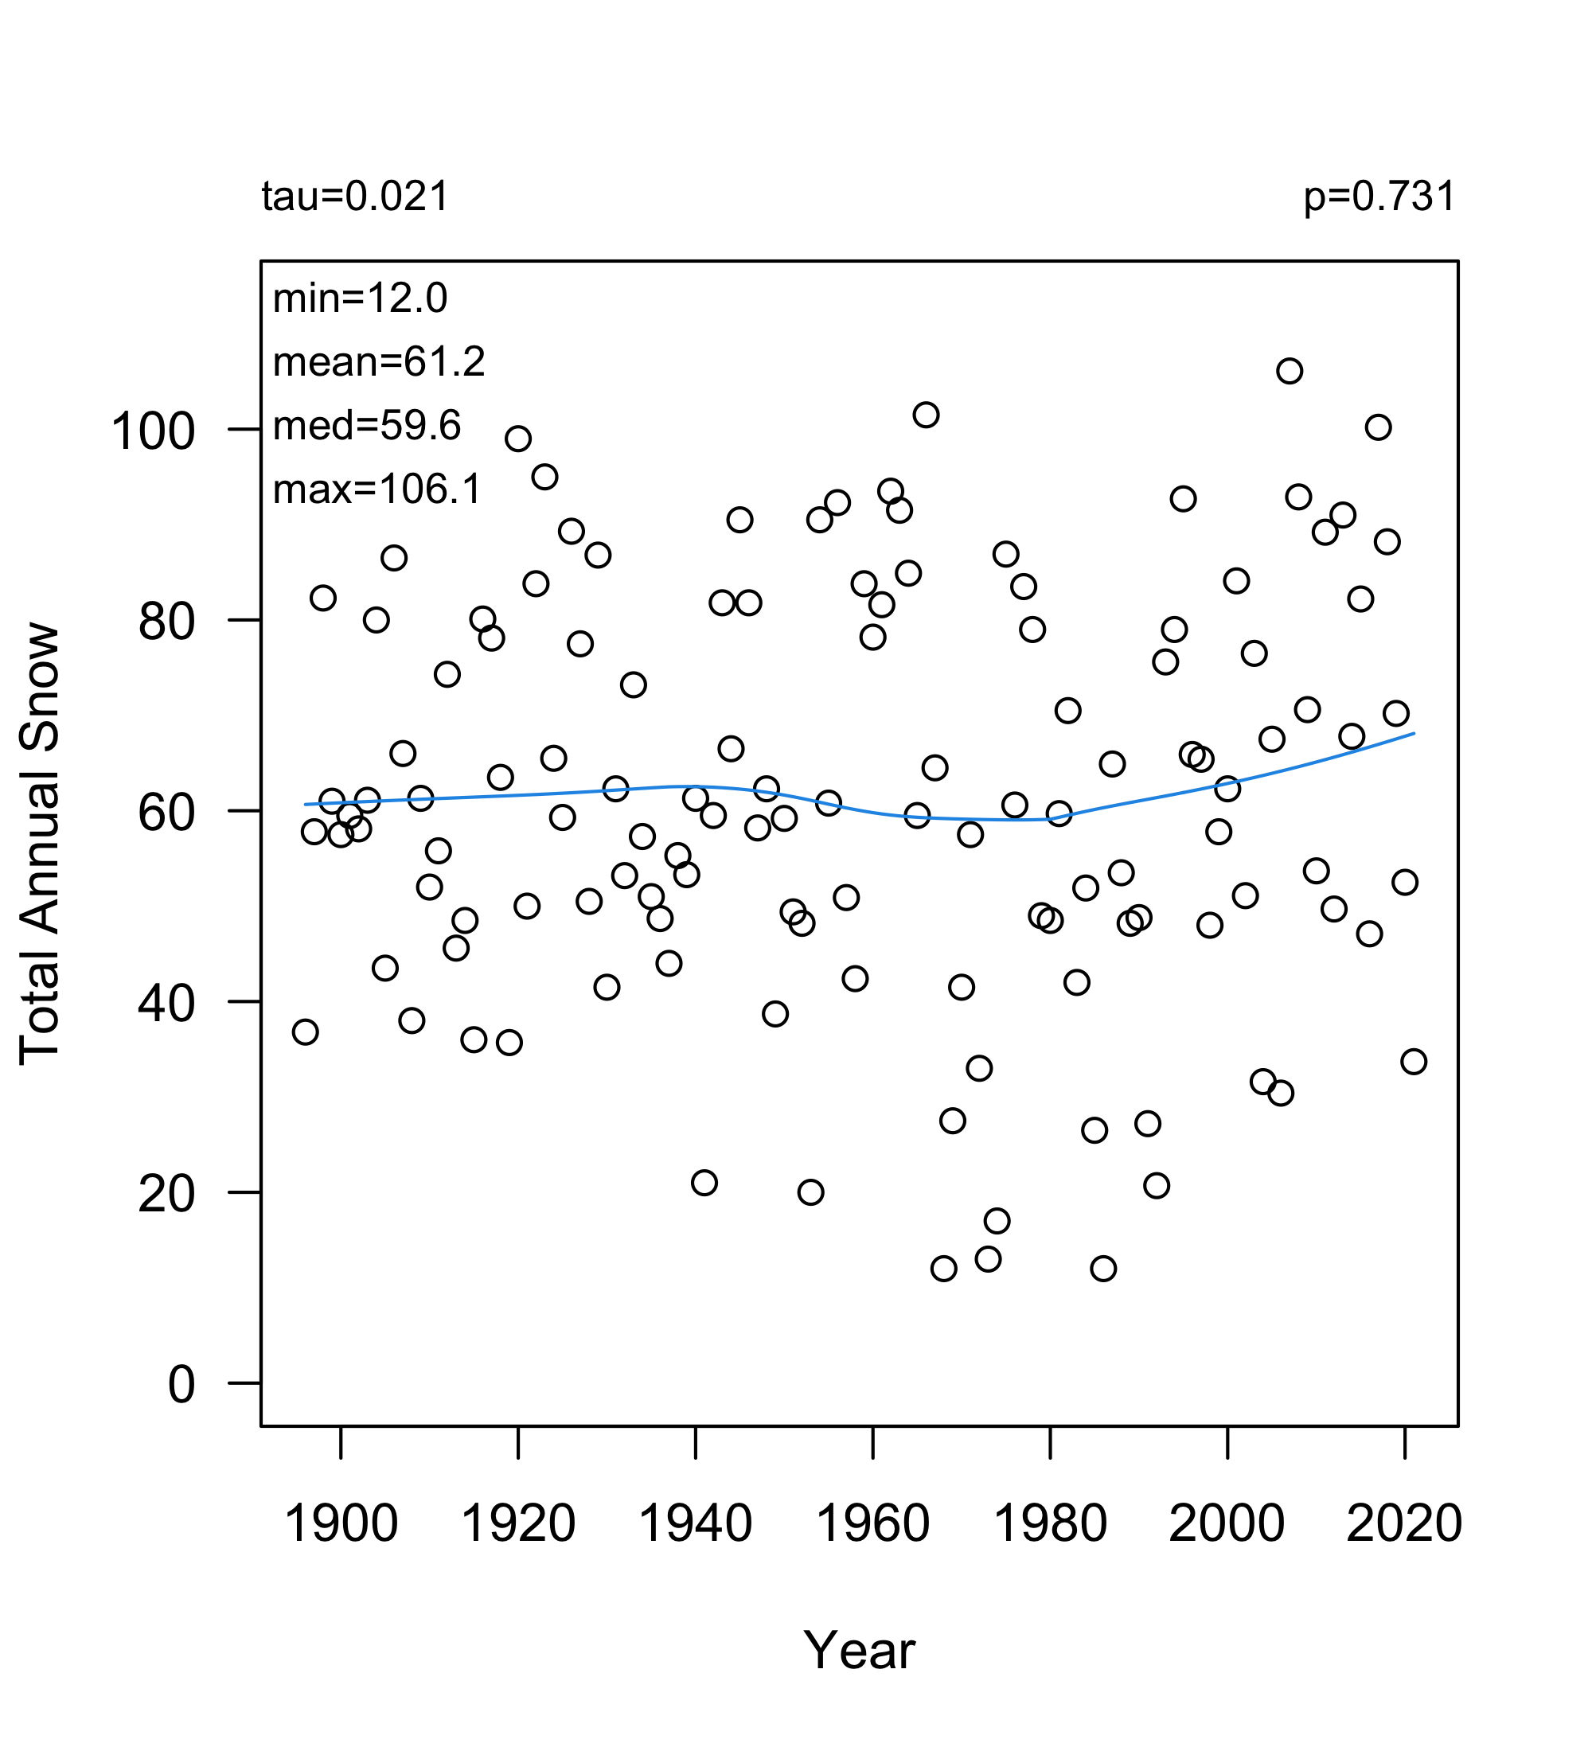

Overlap with water quality data (1977 – 2021):

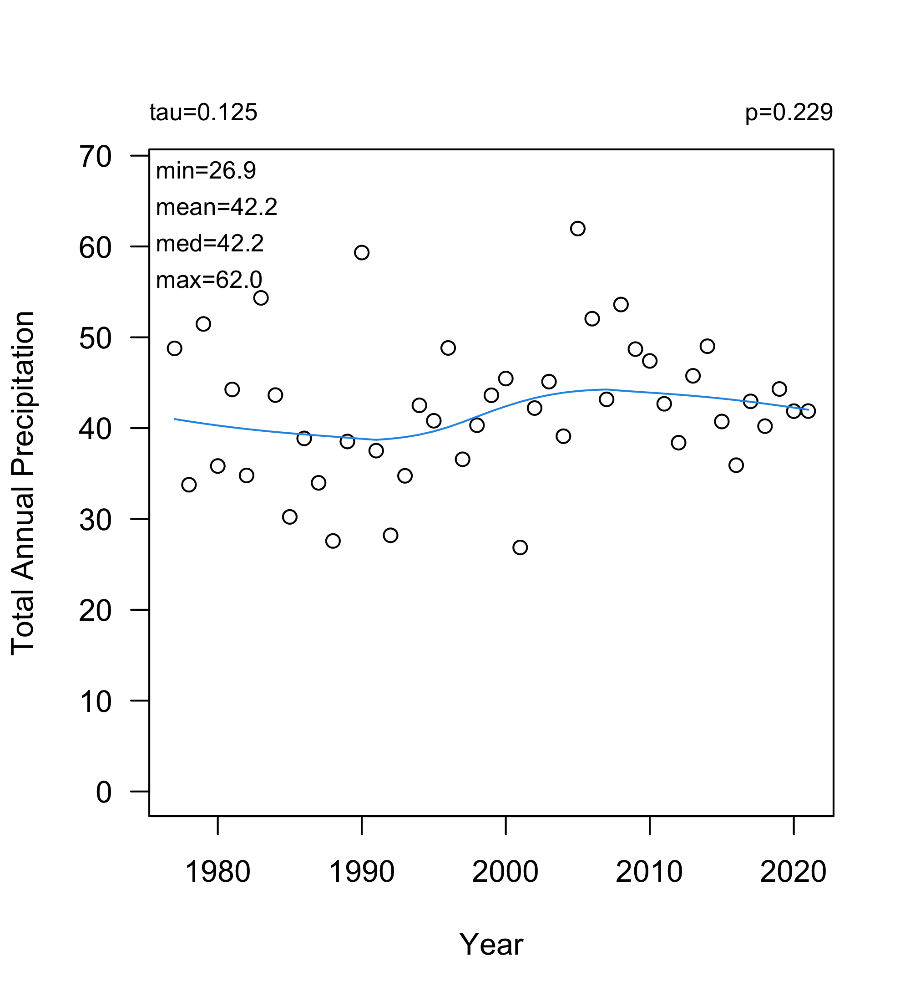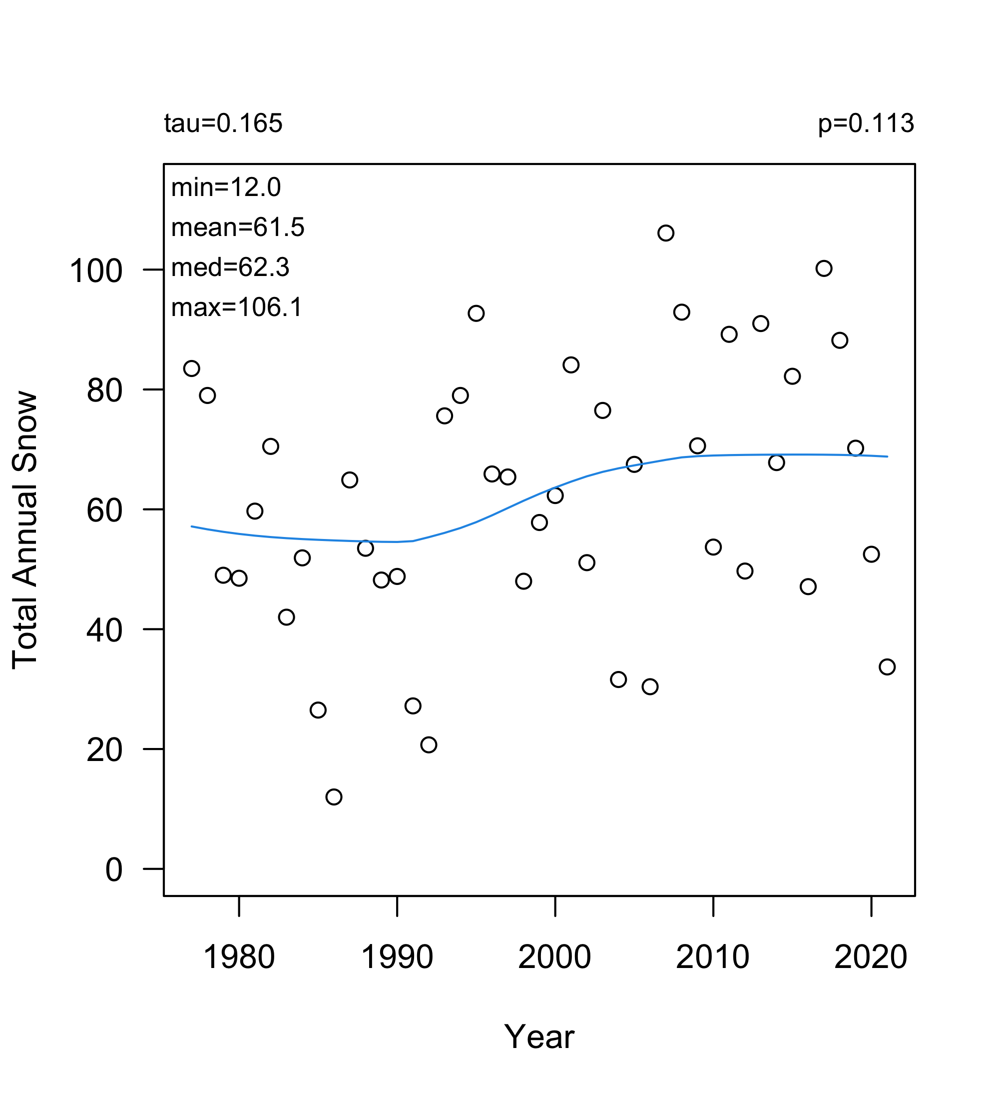

Past 10 years (2012– 2021):

